🗺️ Your Go-Live Roadmap
Stage 1: Let the Bot Run & Observe (Now → 2 Months)
Your bot is already running in Paper Trading mode. Right now, you need to:
- Just let it run — Keep docker-compose running 24/7 on your machine
- Watch the logs occasionally with docker-compose logs -f web to make sure it's not crashing
- The bot is collecting data automatically — every analysis cycle, it saves a FeatureSnapshot to the database with all indicator values. This is your ML training data.
- Target: 200+ paper trades logged — This takes approximately 4–8 weeks depending on market conditions

Stage 2: Analyze What the Bot Is Doing (After ~2 weeks)
Once you have a few hundred decisions logged:
- Open your database file d:\foreks\foreks.db with a free tool like DB Browser for SQLite
- Look at the decisions and trades tables to see which pairs it traded, what confidence it had, and whether they would have been profitable

Stage 3: Run the Backtester (Parallel to Stage 1)
While Stage 1 is running in the background, you can test with historical data right now:
- Download a free Dukascopy CSV file from dukascopy.com/swiss/english/marketwatch/historical/ (free, no account needed) for EURUSD
- Place it in d:\foreks\data\ folder
- Run the backtester to see how the bot would have performed over the past year

Stage 4: The Go-Live Checklist
The plan has a strict gate — you must pass ALL of these before using real money:

Check Required
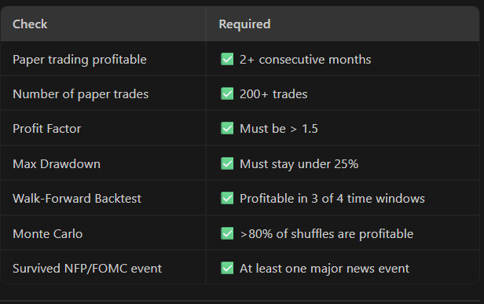
Paper trading profitable ✅ 2+ consecutive months
Number of paper trades ✅ 200+ trades
Profit Factor ✅ Must be > 1.5
Max Drawdown ✅ Must stay under 25%
Walk-Forward Backtest ✅ Profitable in 3 of 4 time windows
Monte Carlo ✅ >80% of shuffles are profitable
Survived NFP/FOMC event ✅ At least one major news event
Stage 5: Go Live With Minimum Risk
Only when ALL checks pass:

Change .env: PAPER_TRADING_MODE=false
Start with 0.01 lot size (micro lots) — minimum possible
Keep MAX_RISK_PER_TRADE_PCT=1.0 (drop it below your current 2.5%)
Monitor closely for the first 2 weeks
IMPORTANT

The most important thing right now: Just keep the bot running and be patient. You cannot rush the 2-month paper trading phase — it's how you protect your real money. The bot is already working correctly and collecting data. You don't need to do anything else today.

While you wait, would you like me to set up the Dukascopy historical downloader so you can run the backtester in parallel?

